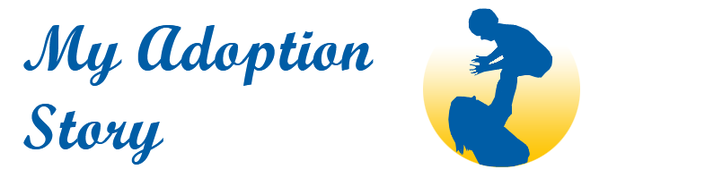

CELEBRATE WORLD ADOPTION DAY
November 9th

Dear Teacher,

In March of this year our small Galway-based committee launched
My Adoption Story at www.myadoptionstory.ie Our site represents a growing collection of stories from people whose lives have been changed forever by adoption – stories from birth mothers, adopted persons and adoptive families. Please take a chance to view.

To be adopted means ‘to belong’ to a family and this comes across clearly in the personal stories on our site.

Our committee has now set a new and ambitious goal to establish a National Adoption Day in Ireland in 2019. We are reaching out to you for help.

As part of our preparations for a National Adoption Day we would like to develop a teaching resource for primary schools which would enable teachers to broach the subject of adoption with their pupils, in a sensitive and appropriate way.

Request
To this end, we are asking you for your help to trial some simple lesson plans with your pupils. Your feedback is very important to us.

Enclosed please find three suggested lesson plans, split into Junior, Middle and Senior classes. Created by teachers for teachers, these lesson plans are designed to be inclusive, educational and fun. They are a creative and fresh way to fulfil the criteria for the SPHE curriculum content, based on the strand unit of Myself and my family.

There are over 50,000 adopted people in Ireland today. It is quite likely that many children in our schools will know of someone who has been adopted but may not understand what it means or why decisions are made to adopt. Our intention with the lesson plans is to allow the topic of adoption to be opened up in a safe, respectful and confident way.

There is a beautiful poem enclosed in your pack ‘Legacy of an Adopted Child’ which sums up the meaning of adoption perfectly. It could be shared with older pupils. A birth mother gave it to an adoptive mother (on our committee) when her baby was placed in her family. Very special.

Why this week?

We are writing to you in particular this week because World Adoption Day www.worldadoptionday.com takes place on Friday November 9th. You and your class can take a moment to hop on to this website and register. Dúlra, from our committee, is in contact with World Adoption Day and they would love to see Ireland making a real splash this year. Hence the colour in our lesson plans!

I am attaching a one page template for your feedback regarding your adoption lesson trial. Your feedback is valued. We want to get this right!

If you require further information please email contact@myadoptionstory.ie

Le gach dea-ghuí,

Fidelma Healy Eames Dúlra O’Broin
Founder Primary teacher

DON’T FORGET TO CELEBRATE WORLD ADOPTION DAY ON NOVEMBER 9TH
Register at www.worldadoptionday.com

My Adoption Story steering committee
Fidelma Healy Eames; Maura Long, Dúlra O’Broin, Luc Desbonnet, Mary Healy, Gerardine Costello, Dónal Cahill, Sean Small, Maria O’Mahoney.

CELEBRATE WORLD ADOPTION DAY
9th November

JUNIOR CLASSES

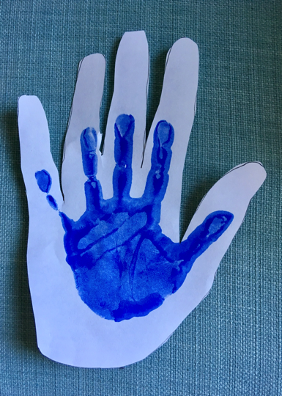
Talk about BELONGING in a family and about people who care for you.
Is there someone who cares for you and who you really like holding hands with?

I Belong
Trace an adult’s handprint (e.g. teacher’s).
Photocopy onto light card.
Each child makes a handprint inside the large handprint. This can be any adult they like to ‘hold hands’ with in their life (eg., mammy, daddy, nanny, grandad, aunty, uncle, ….)
If the teacher wishes, each child can do a second handprint with their other hand inside a second adult hand.
These can be cut out and mounted with a title such as ‘We Belong Together’ or ‘We Belong in our Family’.

Adoption Lesson Theme Songs (perfect for playing in the background during the art activity):

JUNIOR CLASSES: We Belong Together (Randy Newman, Toystory 3)

PLANNING TOOL:
From the SPHE Curriculum
Strand:Myself and others
Strand Unit: Myself and my family
Content Objectives/Learning Outcomes:
- Identify and name the people who constitute a family and appreciate that not all family units are the same.
- Realise how families take care of, support and love each other.

@myadotionstory2018 www.myadoptionstory.ie

CELEBRATE WORLD ADOPTION DAY
9th November

MIDDLE CLASSES
Talk about wishing.
Did you ever make a wish?
Did it come true (yet)?
Sometimes families wish for a child. How can that wish come true?

Holding Hand Poem
You are someone who cares for me
You love me unconditionally
I hold your hand and it steadies me
Walking on a wall or jumping down from a tree
From the palm of my hand along my arm
Into my heart where you belong.

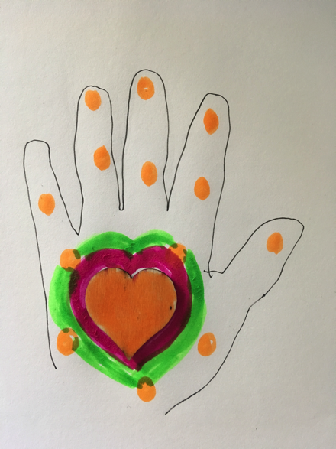

Activity
Each child traces their hand on a piece of card with a dark coloured twistable, colouring pencil or crayola marker. Inside their handprint they draw and colour a heart shape (alternatively pre-cut hearts could be pasted on).
The child could copy the words of the poem around the hand.

Adoption Lesson Theme Songs (perfect for playing in the background during the art activity):
MIDDLE CLASSES: You’ll be in my Heart (Phil Collins)

PLANNING
From the SPHE Curriculum
Strand:Myself and others
Strand Unit:Myself and my family
Content Objectives/Learning Outcomes:
- Identify and name the people who constitute a family and appreciate that not all family units are the same.
- Realise how families take care of, support and love each other.

@myadotionstory2018 www.myadoptionstory.ie

CELEBRATE WORLD ADOPTION DAY
9th November

SENIOR CLASSES

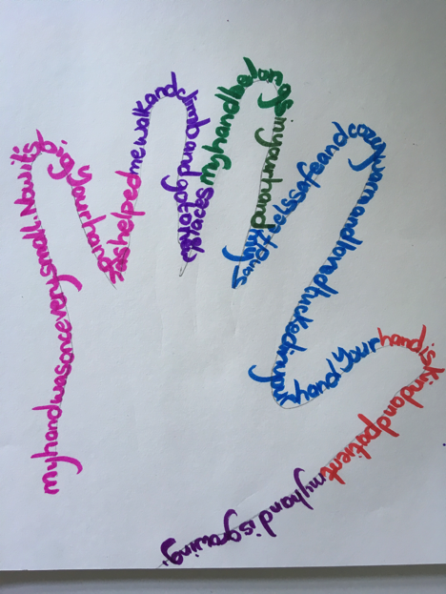
Watch YouTube Video:
In their words -Young people talking about adoption (Adoption Center of Illinois)
https://www.youtube.com/watch?v=SZIUj-d15Ns&t=1s

Discuss with the class how these children describe adoption.
Is all adoption the same?
Are all children adopted at the same age? Do they all have the same story?
Remind the children in your class that each of these children was a wish come true for their Forever Families (Adoptive families) and how wanted and loved they are. Even though their stories may have sad beginnings (the boy talks about feeling lonely, etc.) they find their Forever Families and feel the love, safety and security of that family.

If my Hand could Speak
Each child traces their hand lightly with a pencil. They then write around the shape of their hand with coloured pens, markers, etc. They can write their own words or use the prompts below.

My hand was once very small and now it is this size. Your hand has helped me __________________. My hand belongs in your hand.
My hand feels _________ tucked in your hand. Your hand is______________. My hand is ______________.

Adoption Lesson Theme Songs (perfect for playing in the background during the art activity):
SENIOR CLASSES: I knew I loved you (before I met you) Savage Garden

PLANNING
From the SPHE Curriculum
Strand:Myself and others
Strand Unit:Myself and my family
Content Objectives/Learning Outcomes:
- Explore and discuss families and homes and how they can vary in many ways.

@myadotionstory2018 www.myadoptionstory.ie 091-792017

Legacy of an Adopted Child

Once there were two women who never knew each other.
One you do not remember, the other you call mother.

Two different lives shaped to make you one,
One became your guiding star, the other became your sun.

The first gave you life and the other taught you to live it.
One gave you a nationality, the other gave you a name.

One gave you a talent, the other gave you aim.

One gave you emotions, the other calmed your fears.
One saw your first sweet smile, the other dried your tears.

One sought for you a home that she could not provide,
The other prayed for a child and her hopes were not denied.

And now you ask me through your tears
The age old question, unanswered through the years,
Heredity or Environment, which are you a product of?

Neither, my darling, neither.

Just two kinds of love.

My Adoption Story
Draft lesson plans feedback

1. What worked well? Why?
- What did not work well? Why?
- What improvements are needed to make the lesson(s) work more effectively?
@myadoptionstory 2018 www.myadoptionstory.ie

